
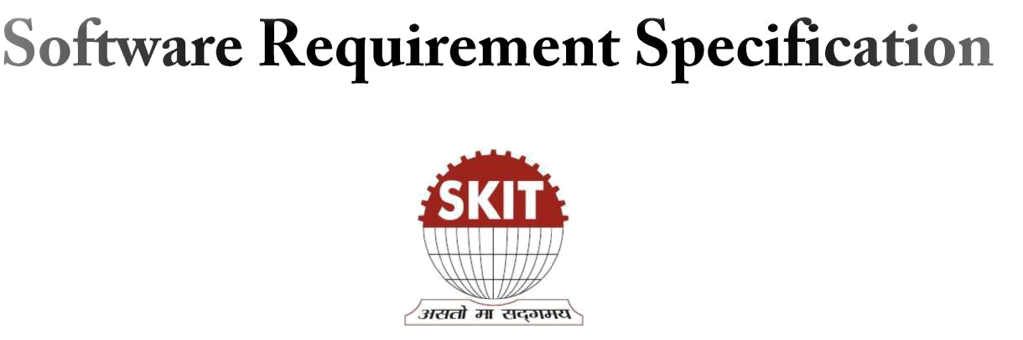

Swami Keshavanand Institute of Technology, Management and Gramothan

Jaipur – 302017

Team Members

Shruti Sarva

13ESKCS089

Shubham Modi

13ESKCS093

Shubham Natani

13ESKCS094

Shubhangi Modi

13ESKCS099

Project Guide:

Mr. Vinod Kr Menaria

Asst. Professor,

Dept. of Computer Science and Engineering

Table of Contents:
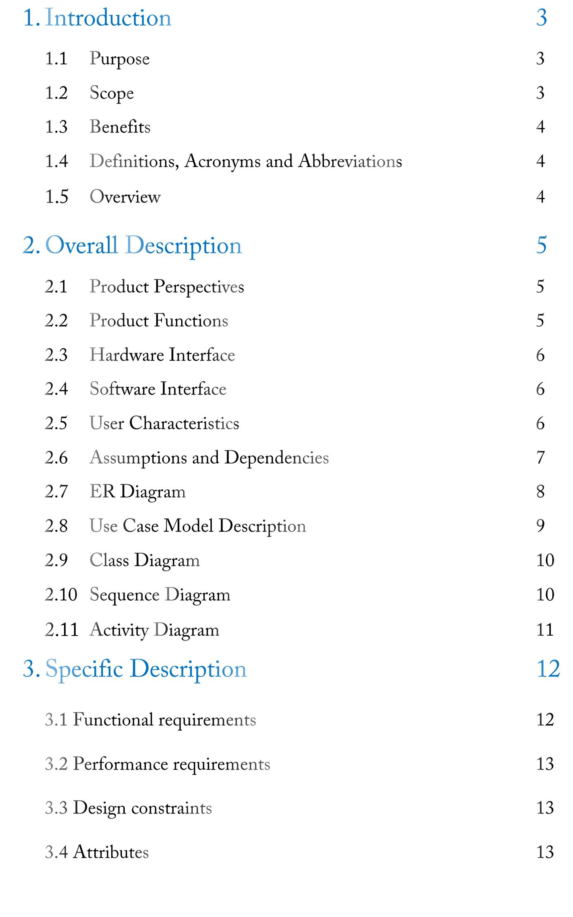

4. References 14

Payroll system is the heart of any Human Resource System of an organization. The solution has to take care of the calculation of salary as per rules of the company, income tax calculation and various deductions to be done from the salary including statutory deductions like Income tax and provident fund deductions. It has to generate pay-slip, cheque summary and MIS reports.

It is understood that we are tired of managing thousands of odd papers, pay slips, payroll reports, and salary details and so on. Imagine that we have a payroll processing system which will generate our pay slips and payroll reports within seconds. We can help others automated your payroll system by developing a customized payroll application that suits your specific requirements.


Main aim of developing Employee Payroll Management is to provide an easy way not only to automate all functionalities involved managing leaves and Payroll for the employees of Company, but also to provide full functional reports to management of Company with the details about usage of leave facility and Salaries paid or to be paid to employees.

We are committed to bring the best way of management in the various forms of EPM. We understand that EPM in not just a product to be sold, it is a tool to manage the inner operation of Company related to employee leave and Payroll.


This Application works in Multiple PC’s installed on multiple Computers by sharing same database by which users of different department can use it sitting at different locations simultaneously.
We have made an Application where the database will be hosted in order to manage the all departments which will be located in different places and by keeping domain of Application as Online.


- To improve the efficiency.

- Quickly find out information of an employee details.

- To provide easy and faster access information.

- To provide user friendly environment.

Visual Basic .NET (VB.NET) is an object-oriented computer programming language that can be viewed as an evolution of the classic Visual Basic (VB) which is implemented on the .NET Framework.

Microsoft SQL Server is a relational model database server produced by Microsoft.

SRS - Software Requirements Specification.

EPM - Employee Payroll Management


The following subsections provide the complete overview of the software specifications requirements documentation for the product Employee Payroll Management. The entire SRS is documented in view of User and the following sub sections are arranged to give a complete outlook of the software, its perspective, features, system requirements and users know how it is.


This software is developed specifically to cater the company employees leave management, is totally self-contained and works efficiently. It provides simple database rather than complex ones for high requirements and it provides good and easy graphical user interface to both new as well as experienced user of the computer.


2.2.1 Employee module

- Designation

- Department

- Employee details

2.2.3 Search module

2.2.4 Attendance module

- Leave

- Attendance

- Managing Leave

2.2.5 Salary module

- Allowance

- Deduction

- Pay Slip

- Memory minimum of 512MB RAM (1GB Recommended)

- Hard disk of 40 GB

- Printer


• | Operating System | Windows XP.
• | Front End | Microsoft VB.Net 2008
• | Backend | MS SQL Server 2008


2.5.1 End Users
- No specific knowledge or skills are required from the end user.

- End user should have basic idea about computer operations and database.

2.5.2 Administrator
- Administrator must be capable to manage user rights.

- If the network connection does not work properly than our system should not work as intended.

- Also that is assumed that the product is installed properly at web server.
  - This system will not take care of any virus problem, which might occur either on the Client or the server system. Avoiding the use of pirated software and ensuring that floppies and other removable media are scanned for viruses before use could minimize the possibility of viral infection.

  - Recovery of data after a system crash will be possible only if backups are taken at regular intervals.

- The product must have an interface which is simple enough to understand.

- All necessary hardware and software are available for implementing and use of the tool.

- The proposed system would be designed, developed and implemented based on the software requirements specifications document.

- End users should have basic knowledge of computer and we also assure that the users will be given software training documentation and reference material.

- The system is not required to save generated reports.

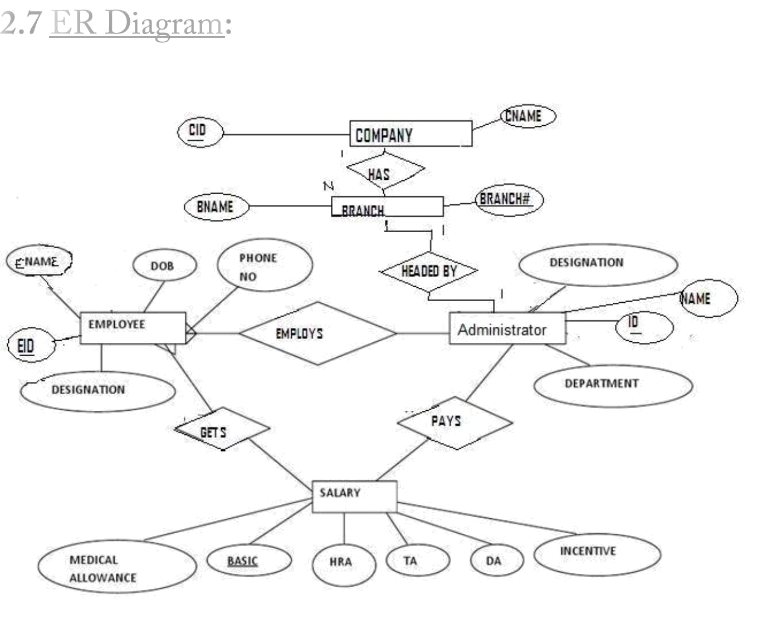

Fig: ER Diagram of Payroll Management System
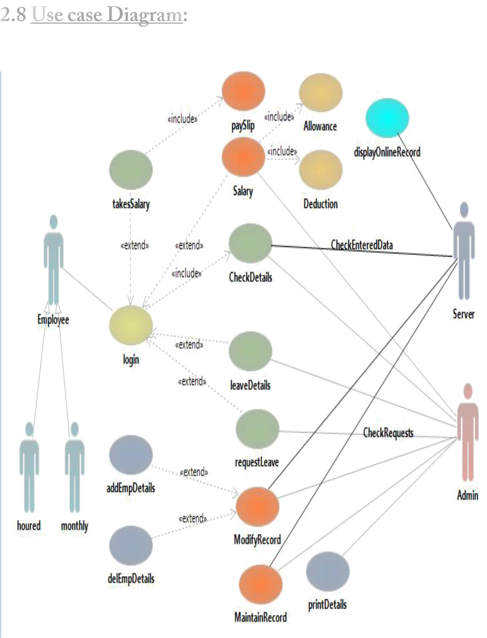

Fig: Use Case Diagram
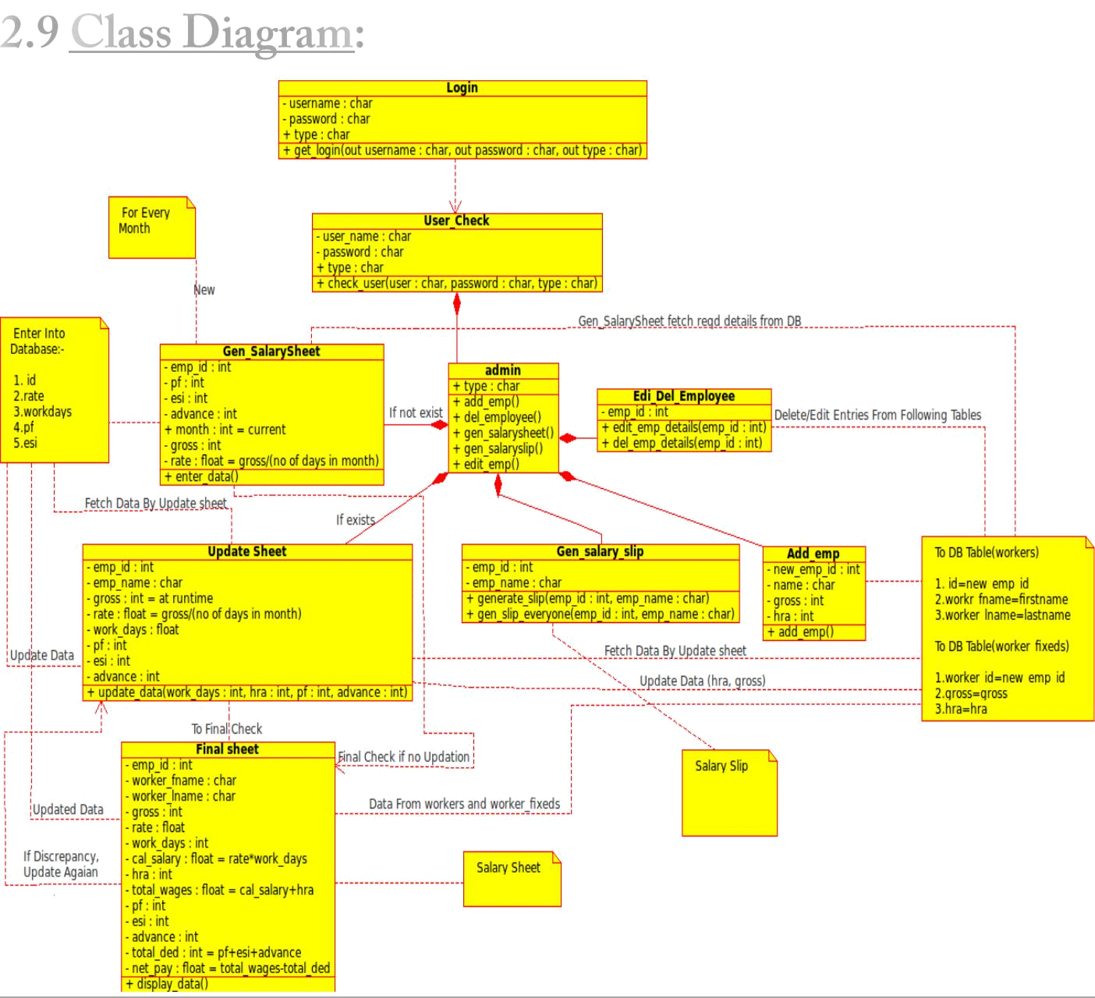

Fig: Complete Class Diagram
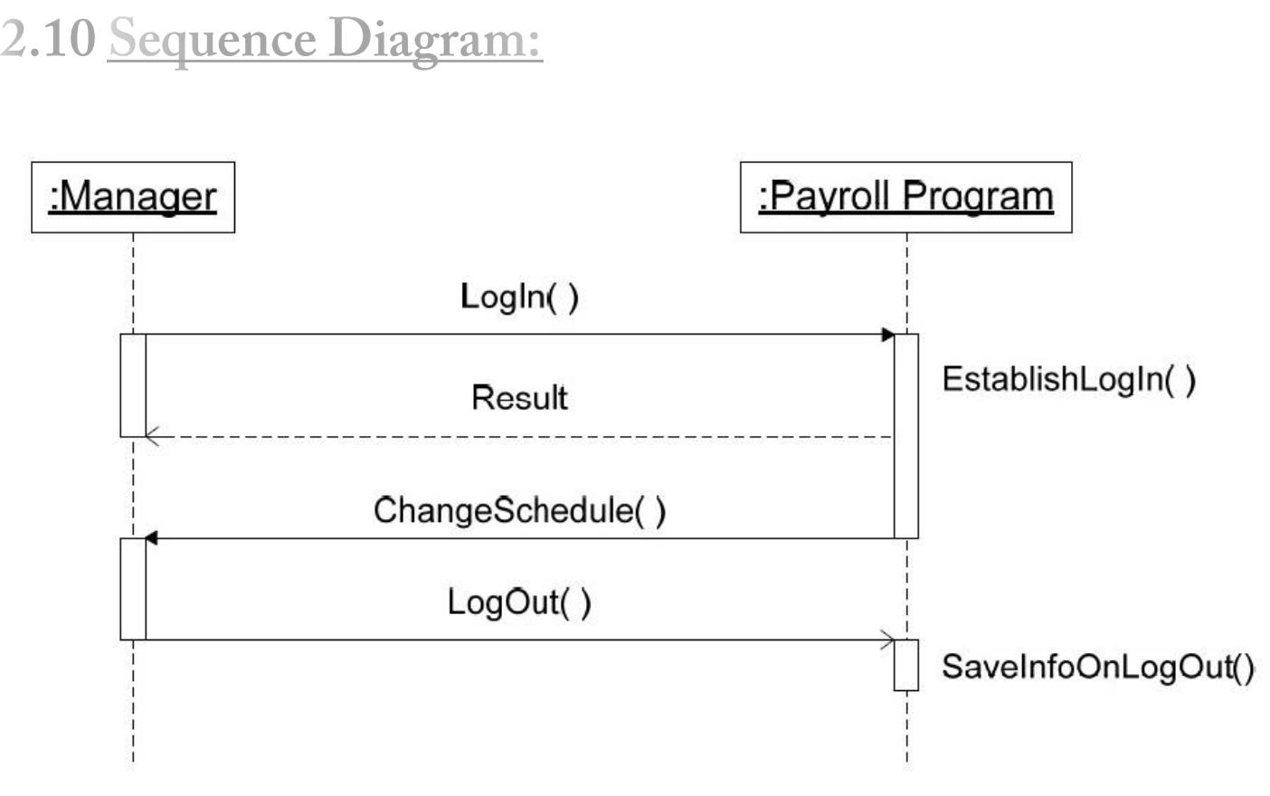

Fig: Sequence Diagram of Manager/ Administrator

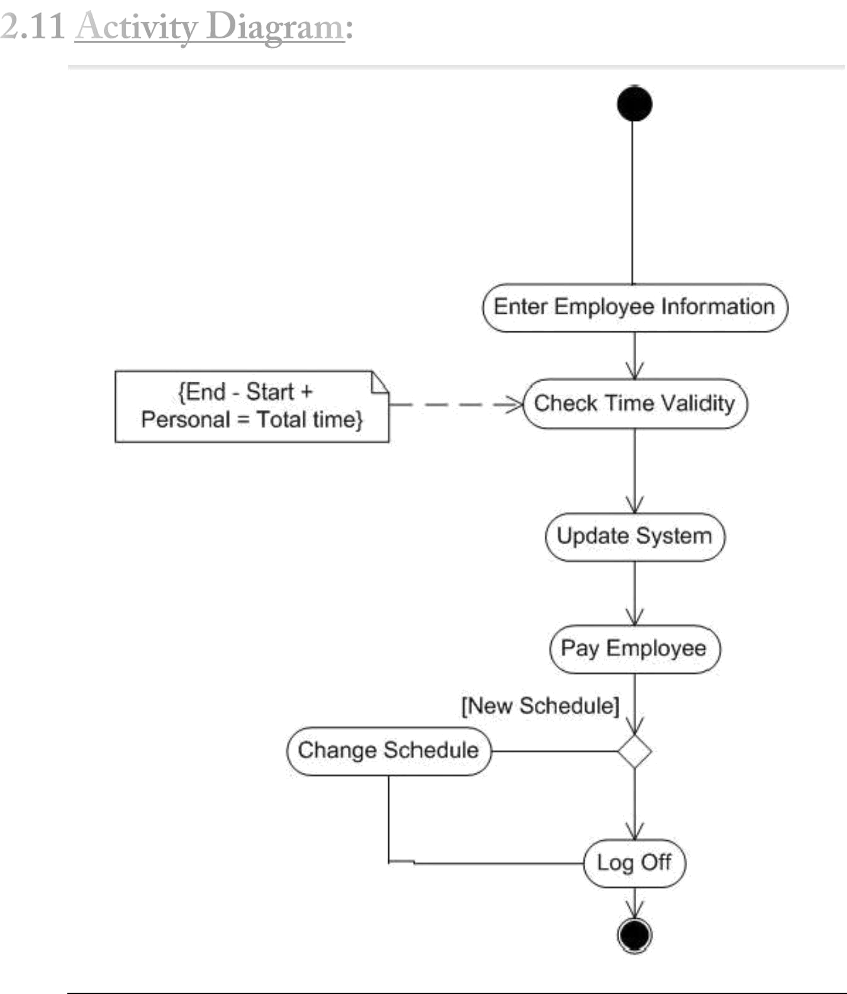

Fig: Activity Diagram of Administrator


3.1.1 Masters:

This module helps the administrator to enter the designation and the related description. It also helps to add the department.

3.1.2 Employee:

This module helps to add the details of the employee like the personal detail and the employee detail.

3.1.3 Search:

This module helps to search the employee details department wise and designation wise.

3.1.4 Attendance:

This module helps to different types of leave for different year. It also helps the employee to enter their entry and exit time. Using the attendance module the employee can also check their remaining leaves and also apply for the leave.

3.1.5 Salary:

This module helps to calculate the salary by adding the allowances and the basic salary and by deducting the deductions based on the leaves and also the PF, ESI. It also helps to generate the employee pay slip.
3.1.6 Report:

This module helps to generate the administrative reports like the Salary Report, Attendance Report and the Employee Report which is in can be exported to word, pdf.
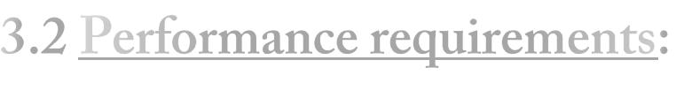

  - The overall system should be fast and error free.

  - It should have built in error checking and correction facilities.

  - The system should be able to handle large amount of data comfortably.

- The system runs under Windows XP / 7 / 8 / 8.1 or Any version of Linux.

- The application is developed on VB.Net platform and SQL server 2008 as back end.



3.4.1 Reliability

In order to ensure reliability, this system is being designed using software that is established to be stable and easy to use.

3.4.2 Availability

This system is designed to run 24/7 and be readily available to the user.

3.4.3 Security

The access to the software is given only to valid operators. We need a specific ID and password to get access to the software.

- Wikipedia.org

- Programming Visual Basic .NET, Second Edition by Jesse Liberty

- Jones and Bartlett Publishers - Essential SQL on SQL Server 2008, 2011

- Software Engineering by “Ian Sommerville”.

